DATING LIFE QUESTIONNAIRE FOR ADULTS WITH AUTISM
Carlos Castañeda, a Doctoral Student at Texas Tech University in the department of Educational Psychology, Leadership & Counseling, and Dr. Nicole Noble, Assistant Professor in the Counselor Education program, are conducting a research study on the challenges of social dating life for adults with autism spectrum disorder.
For this study, we are looking for adults over the age of 18 who are on the spectrum. If you participate in this online survey, you will be asked to complete a survey that will take less than one hour to complete. Your participation is completely voluntary, and you can stop at any point in the study.

If interested in participating, please use your camera to scan the QR code and this will direct you to the survey.
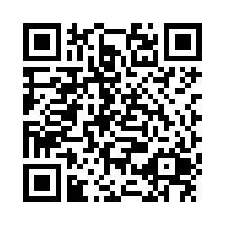
If you have any questions about this study, please feel free to contact Dr. Nicole Noble the Principal Investigator of this study at nicole.noble@ttu.edu or by calling 806-834-7629. You may also contact the Human Research Protection Program at Texas Tech University for any questions regarding the rights of participants. Their phone number is (806)-742-2064, and their email is hrpp@ttu.edu.

